Parallel and Distributed Computing

CSE4001

Fall Semester 2020-21

Lab Assignment 10

**ISHAAN OHRI**

**18BCE0265**

**Aim:**

Assume the variable rank contains the process rank and root is 3. What will be stored in array b [ ] on each of four processes if each executes the following code fragment?

int b [4] = {0 , 0 , 0 , 0};

MPI_Gather ( & rank , 1 , MPI_INT , b , 1 , MPI_INT , root ,MPI_COMM_WORLD);  
  
Hint. The function prototype is as follows:

int MPI_Gather (

void * sendbuf , // pointer to send buffer

int sendcount , // number of items to send

MPI_Datatype sendtype , // type of send buffer data

void * recvbuf , // pointer to receive buffer

int recvcount , // items to receive per process

MPI_Datatype recvtype , // type of receive buffer data

int root , // rank of receiving process

MPI_Comm comm ) // MPI communicator to use

**Source Code:**

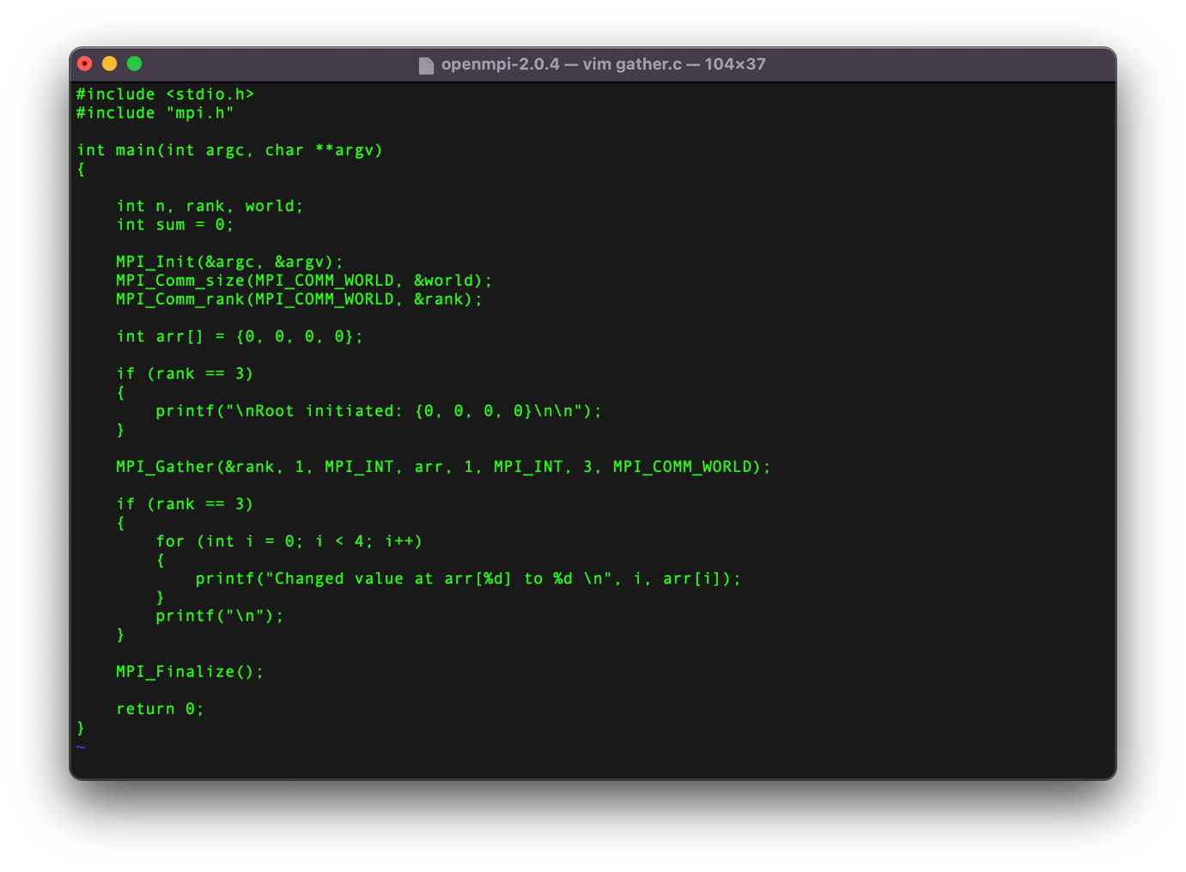

**Execution:**

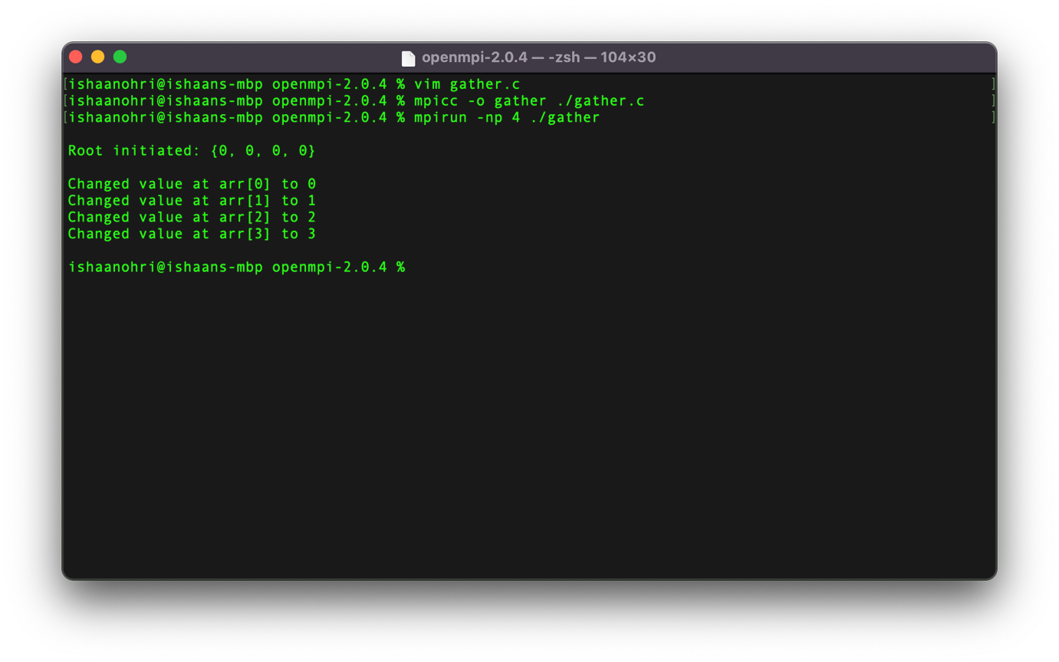

**Remarks:**

int MPI_Gather(const void *sendbuf, int sendcount, MPI_Datatype sendtype, void *recvbuf, int recvcount, MPI_Datatype recvtype, int root, MPI_Comm comm)

In the MPI_Gather command following are the meaning of all parameters:

sendbuf => starting address of send buffer (choice)

sendcount => number of elements in send buffer (integer)

sendtype => data type of send buffer elements (handle)

recvcount => number of elements for any single receive (integer, significant only at root)

recvtype => data type of recv buffer elements (significant only at root) (handle)

root => rank of receiving process (integer)

comm => communicator (handle)

Initially the array arr is declared as {0, 0, ,0 ,0} and then by the use of MPI_Gather we get the values changed to {0, 1, 2, 3}. Each and every root is sending its rank as the sendbuff. These received values are stored at the respective indices of the final root array. These value are displayed iteratively.